Screenshots of Webpages for Lab Task 3.1 to 4.1
Name: Woon Xin Ying
ID: 105198939
Lab 3
Lab Task 3.1
https://github.com/Sharonwoon/DataVIsualisationLab/blob/main/Lab3-1.html
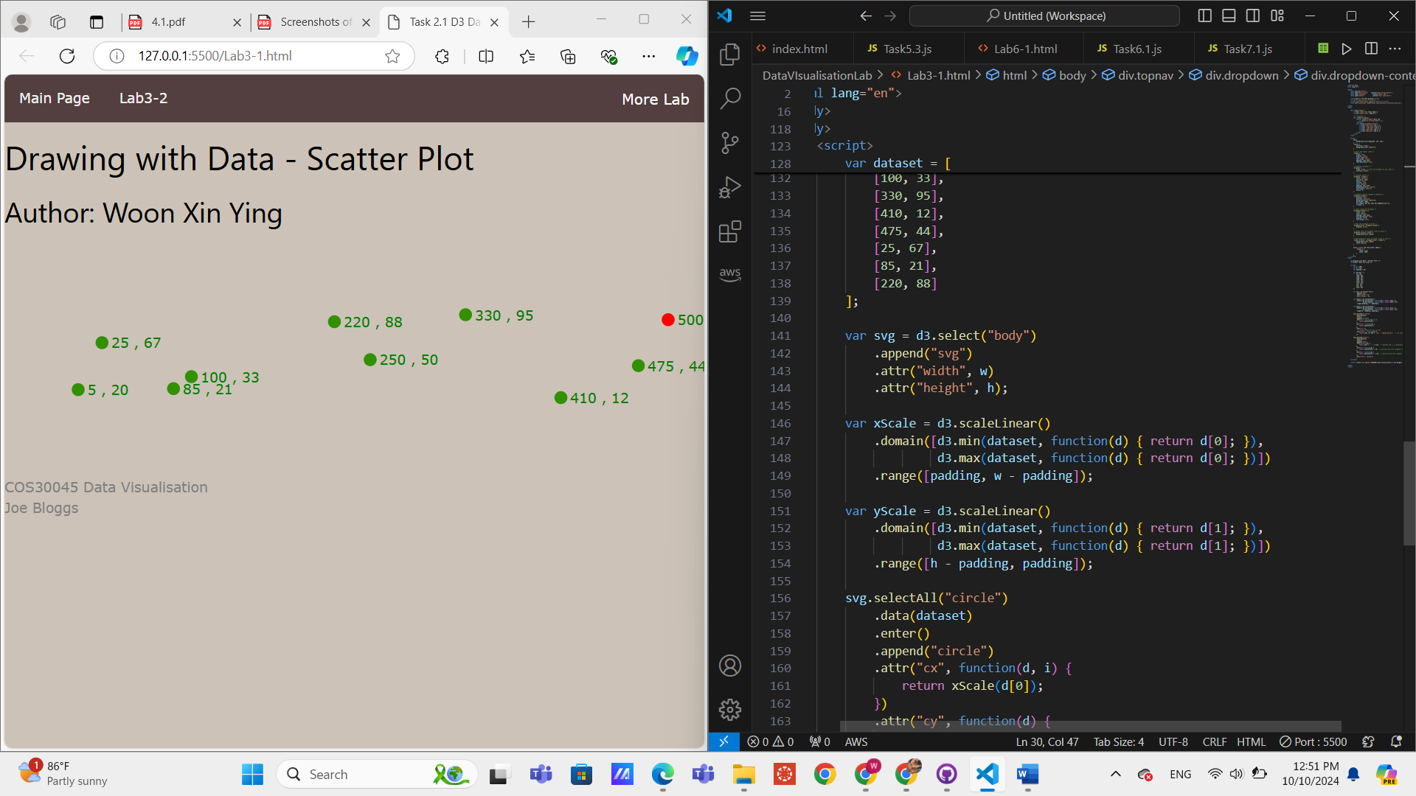

Lab Task 3.2
https://github.com/Sharonwoon/DataVIsualisationLab/blob/main/Lab3-2.html

